**What is 64bit means?**

A bit refers to one binary digit, which is the smallest amount of information a computer can record. 64-bit numbers have bits containing eight sets of bytes.

64-bit processors can process 64bit of instruction per second.

64-bit system can utilize a higher amount of ram.

**Computer hardware…...**

**2018**

The Central Processing Unit (CPU) of a computer is comprised of three main parts. Briefly explain these three (3) parts.

**ALU** – is a **digital circuit** used to **perform arithmetic and logic operations of the computer**.  
  Examples of arithmetic operations are addition, subtraction, multiplication, and division. Examples of logic operations are comparisons of values such as NOT, AND, and OR. it also **performs bit-shifting operations**.

**CU** – a digital circuitry within the processor that **coordinates data movements into, out of, and between the processor’s subunits**. It is the **responsibility** of the Control Unit **to tell the computer’s memory, arithmetic/logic unit, and input and output devices** how **to respond to the instructions** that have been sent to the processor. It **decodes instructions**.

**Registers** – The computer needs **processor registers for manipulating data** and **a register for holding a memory address**. The sole purpose of having a register is **fast retrieval of data for processing by CPU**. They are **faster than cache memory**.

Memory and Storage

Briefly explain the types and characteristics of primary and secondary memory.

* **The types of primary memory are**,

**Registers**

**Main memory**

**Cache**

* **Types of secondary memory**

**Solid state drives**

**Optical devices – cd DVD**

**Magnetic storage devices – hard disk**

* Primary storage is the component of the computer that holds data, programs, and instructions **that are currently in use**. It **stores data temporarily**. Primary storages are **volatile except ROM**.  
  Primary memory **can be directly accessed by the CPU**.
* Secondary memory is a storage device that **cannot be accessed directly by the CPU**. It is used as **a permanent storage device**.   
  The CPU accesses these devices **through an input/output channel**, and data is first **transferred to primary memory from secondary memory** before being accessed.

|  |  |
| --- | --- |
| **primary** | **secondary** |
| Stores data temporarily | Stores data permanently |
| CPU can directly access | CPU cannot directly access |
| Data is stored inside semiconductor chips | Stored on external hardware such as hard drive… |
| faster | slower |
|  |  |

Both primary and secondary memories are crucial for a computer’s efficient functioning.

Explain four (4) storage device features.

* Volatility
* Accessibility
* Mutability
* Addressability

**Volatility –** there are two types of storage devices according to volatility.   
Volatile and non-volatile.   
**In volatile storages** such as Ram, the data will be lost when the power is down. Therefore, they require constant power to maintain the stored information. But they are fast.  
But **in non-volatile storages**, the data is stored permanently hence they won’t be lost when there is no power. suitable for long-term storage of information.

**Accessibility** – the types of accessibility in storage devices are **Random access**, **sequential access**, **direct access**, and **associate access**.

**Mutability** – mutability has three categories.   
Read/write(mutable) storage, read-only storage, slow write fast read storage.  
**Read/Write storage** allows information to be overwritten at any time.  
**In Read-only storage,** the information is written once after manufacture, and it can be read many times.

**Slow write, fast read storage** allows information to be overwritten multiple times but with the writing operation being much slower than the read operation.

**Addressability –** addressability has 3 categories.  
Location-addressable, File addressable, Content-addressable.

**Location-addressable** each **individually accessible unit of information** in storage is selected with its numerical memory address.

**File-addressable,** although the underlying device is location addressable the information is divided into files, and a particular file is selected with human-readable directory and file names.

**Content-addressable** each individually accessible unit of information is selected based on the parts of the contents stored there. Ex: CPU cache

**Using the examples explain Random Access and Sequential Access.**

**random access –** any location in storage **can be accessed at any moment at approximately the same time. Physical locations are independent** in this access method. Applications RAM and ROM.

**sequential access –** in this method, **the memory is accessed in a specific linear sequential manner** (one after the other). Therefore, the **access time depends on** **the location of the data** and **which piece of information was last accessed**. Applications are magnetic tapes and magnetic disks.

**2019**

**A computer system is comprised of many short-term and long-term storage devices. All these storage devices create a hierarchy of components. Draw a diagram illustrating the features of this hierarchy and describe the characteristic features of this hierarchy.**

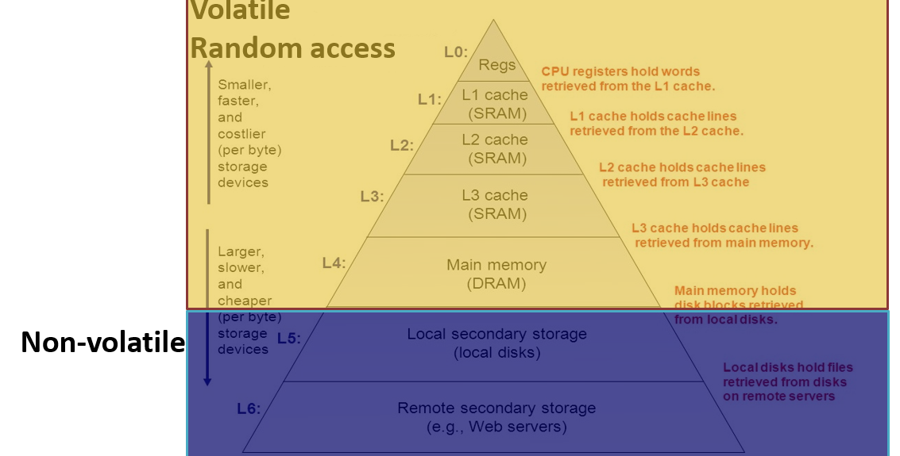

**2017**

**How many bits are used to address the memory locations of a PC's memory, if the PC has**

**2GB of main memory (RAM)?**

**2GB = 232 bytes**

**Number of bits = Log 2(2m) = m**

**Log 2(232) = 32-bit address**

**2014**

**Briefly explain how the cache memory works**

**CACHE memory**

Cache memory is a small amount of fast memory that **sits between normal main memory and CPU**.



It **acts as a temporary storage area where the CPU can retrieve data easily**.

Cache memory is **used to reduce the average time to access data from the Main memory**.

**Cache works on** the principle of **locality of reference**.

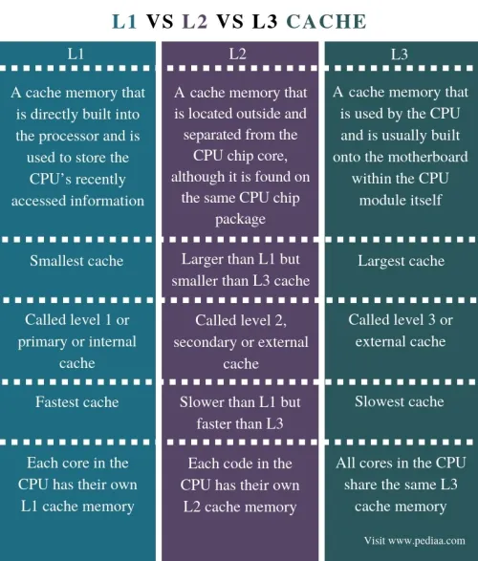



**2017**

**Explain how the Cache Memory increases the speed of a PC**

Fast CPUs are useless if they must retrieve data directly from comparatively slow main memory. Therefore, cache memory is used to **speed up and synchronize with the high-speed CPU**. Cache Memory is a special very high-speed memory. It **acts as a buffer between RAM and the CPU**. It **holds frequently requested data and instructions** so that they are **immediately available to the CPU** when needed.  
Cache memory **stores copies of the data from frequently used main memory locations**.   
  
  
When the processor needs to read or write a location in the main memory, it **first checks for a corresponding entry in the cache**.   
If the processor finds that the memory location is in the cache memory **cache hit occurs** and the CPU reads the data from the cache.  
Otherwise, a **cache miss occurs**, and the cache copies data from the main memory.

**2014**

**What does it mean by "Locality of Reference”?**

**2015**

**What do you mean by "Cache works on the principle of locality of**

**reference"**

Cache memory is based on the principle of locality of reference. There **are two ways in which data or instruction is fetched from the main memory and get stored in cache memory**. These two methods belong to the locality of reference principle.

The locality of reference refers to a phenomenon in which a **computer program tends to access the same set of memory locations for a particular time period**. (temporal) in other words, it refers to the tendency of **a computer program to access instructions whose memory locations are near one another**. (spatial)

# 

**What does it mean by "Memory Refresh"?**

Memory refresh is a process that periodically reads data from an area of computer memory and immediately writes that read information to the same area without modification.

**Briefly describe Read Only Memory (ROM) and Random Access Memory (RAM)?**

|  |  |
| --- | --- |
| **RAM** | **ROM** |
| Store instructions and data that the CPU requires in the execution of programs. | Store crucial data that are essential to operate the system such as how to boot the computer. |
| **volatile** | **Non-volatile** |
| **Temporary storage** | **Permanent storage** |
| Semiconductor memory | Always retain its data |
| **Dynamic** memory | **Static** memory |
| **Slower** than ROM | **These cannot be accidentally changed** |
| **Writing data is faster** | **Writing data is slower** |
| Two types: **SRAM DRAM** | Three types: **EPROM, PROM, EEPROM** |

PROM – can program only once. After that instructions cannot be changed.

EPROM – can program multiple times by erasing all by using ultraviolet light.

EEPROM – can program multiple times by erasing all or only a portion of data by applying an electrical field.

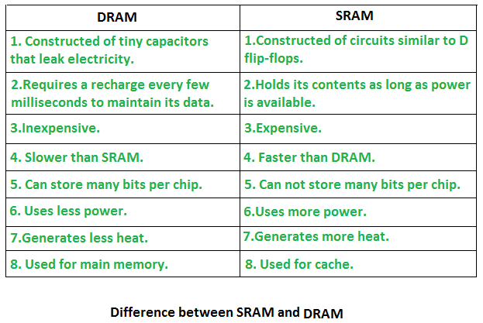

**2016**



|  |  |
| --- | --- |
| **Static memory** | **Dynamic memory** |
| No **charges to leak**... **flip flops** are used. | Bits are stored as **charge** in **capacitors**. |
| No **refreshing** needed | Need refreshing even when powered on |
| More **complex construction** | Simpler construction |
| Larger **implementation per bit** | Less implementation per bit |
| More **expensive** | Less expensive |
| **Faster** than dynamic memory | Slower than static memory |

**Main Memory can be made faster by using static memory. Then why don’t we do that?**

because static memory is more expensive and takes a larger implementation per bit.

Hence, dynamic memory supports greater densities at a lower cost per bit.

**2018**

**Briefly explain the types of storage and their characteristics.**

* **Primary**
* **Secondary**
* **Tertiary**
* **Offline**

Usually, **primary memory** storage is used to **store the data directly used by the CPU**. Primary memory storages are **Main memory, Registers, and Cache**. Main memory is again divided into **RAM** and **ROM**.

Secondary storage is **used to store data permanently** and they **can’t be directly accessed** by the CPU. Data in the secondary storage devices are **accessed through I/O channels** and then primary storage. Examples are **hard disk** and **SSD**.

Tertiary storage **involves a robotic mechanism that mounts and dismounts** **mass storage media** **into storage devices**. This is a **very slow process,** so this is used to archive data that is not frequently used.

Offline storage, aka **disconnected storage**, is storage devices that **are not under the control of the processing unit**. It must be **inserted into storage media manually** to access data. Examples are CDs, DVDs, USB flash drives, and memory cards.

**2017**

**The data access time of Hard Disk Drives**

**Access time = seek time + rotational delay + transfer time**

**Seek time -** track selection time

**Rotational delay –** the time it takes for the header **to reach the beginning of the sector**

**Transfer time -** the time required to transfer data

**Data representation**

**Digitization** is the process of converting data such as images, text, videos, or music into a digital form that can be manipulated by electronic devices.

**Data representation** refers to the form in which data is stored processed and transmitted.

Qualitative data – descriptive data

Quantitative data – numerical information

Discrete data: can only take certain values (countable)

Continuous data: can take any value within a range (measurable)

* To reduce file size and transmission times, digital data can be compressed.

**.zip**, **.gz**, **.pkg**, or **.tar.gz** compressed extensions.

**OS**

**2018**

**What is an Operating System?**The operating system is a program that **acts as an intermediary** between the **user** of the computer **and the computer hardware**.

**2016**

**What is the relationship between operating systems and computer hardware?**

An operating system acts as a translator between the user and computer hardware.

It provides access to hardware resources and manages the hardware to be efficiently used by users or application programs.

**Explain three (3) operating system functions.**

1. Process management
2. File management
3. Main memory management
4. Secondary storage management

**Process management** –

* **Create/delete** the user or system processes
* **Suspend** & **resume** processes.
* Provides a mechanism for **Synchronization  
   communication  
   deadlock handling**

**File management** –

* **Create and delete** files and directories
* **Access control** to determine access.
* **Mapping files** onto secondary storage
* **Backup files** onto stable storage media.

**Memory management** –

* **Determines what is in memory and when**
* **Optimize computer utilization**
* **Keeping track of** which parts of memory are **being used** and **by whom**.
* **Decide** which process/ data move into and out of memory
* **Allocating** and **deallocating memory space**.

**Secondary storage management** –

* **Manage free space**
* Storage **allocations**
* **Disk scheduling**



* A picture containing diagram

  Description automatically generatedProving a **uniform view of data**



**2018**

**State four (4) services provided by the Operating Systems.**

**2017**



**List down 4 services of an Operating System.**



1. Program execution



1. Error detection ad response
2. Communication
3. File management
4. Security and protection
5. Control I/O device

**Briefly explain two of them**

Program execution – OS is responsible for loading and running programs.

Error detection – OS detects errors in CPU, memory hardware, I/O, or user programs and diagnoses the issues.

Communication – OS exchange information between processes from the same computer or different systems.

**List down 4 classifications of Operating Systems.**

**2016**

**List down 2 classes of Operating Systems and briefly explain each of them.**

Multiprogramming

Multitasking (time sharing)

Real-time operating systems

Mobile operating systems

**Multiprogramming OS**

**One user cannot keep** the CPU and I/O **busy all the time**.

**Multiprogramming organizes jobs** so the CPU always has one to execute.

A **subset of the total jobs** in the system is **kept in memory**.

Jobs get executed one by one using **job scheduling.**

If a job has to wait (for I/O) then **OS switches to another job**.

**Multitasking OS**

Executes **many programs** at **the same time** by **swapping every program** in and out of the memory **simultaneously**.

Using **CPU scheduling** split CPU time among all users.

**Response time** should be < 1 sec.

**Each user** has at **least one process** executing.

**Virtual memory** allows the execution of processes that are not completely in memory.

**2018**

**Explain why computers need an Operating System.**

Operating systems play an important role in **managing software, hardware, processes, and memory**. Without an operating system a computer would be useless. Because the **hardware can not communicate with software.**  
Operating system **let users and programs to communicate with hardware resources**. It allows the **user to run programs on a computer**. It **tells the computer what to do by controlling the system components**. Therefore, an OS is needed for a computer to function.

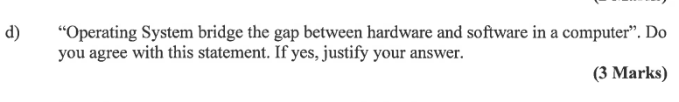**2016**

I do agree.

Hardware or software cannot work individually. They must come together to get the work done. If there was no connection between computers hardware and software, it would be useless because they can’t communicate with each other. An operating system (OS) provides a virtual execution environment on top of hardware that solve this problem. It manages hardware resources and provide access to the software.

**Networking**

**2018**

**List four major elements of a computer network.**

Devices – to communicate with one another.

Medium – to connect devices together

Messages – information to be transferred through the network

Rules – to govern the network

**Based on the covered geographical area, computer networks can be divided into three categories: Local Area Networks (LANs), Wide Area networks (WANs) and Metropolitan Area Networks (MANs). Briefly explain LANs and WANs including following details:**

**a. Size of the network**

**b. Network devices used**

**c. Technologies used**

**LAN –**

Size – LAN networks cover relatively smaller geographical areas such as office/ school building.

Network devices – **switches, Wi-Fi routers**, hubs, bridges

Technologies – Ethernet, Fast Ethernet, Gigabit Ethernet, wireless LAN, token ring, token bus

**WAN –**

Size – wide area networks cover geographically huge areas and consist of geographically dispersed collection of LANs.

Network devices – routers, ADSL routers, WAN switch (L3), servers

Technologies – dial up connections, ADSL connections, Leased lines, VPN, frame relay

MAN –

Size – metropolitan area network covers an area larger than LAN but smaller than WAN, such as a city. Made by interconnecting different LAN s.

Network devices – Modem, point-to-point Wi-Fi, wireless LAN

Tech – ATM (Asynchronous transfer mode), ISDN (integrated services digital network), ADSL

**2017**

**List down three network devices you can only find in a LAN.**

Switch, Hub, Wi-Fi router

**List down three network devices used to build WAN.**

WAN switch, Router, ADSL router, Multiplexer